Predicting Yelp Review Score with Ensemble Learning of MLR and Random Forest - Group 5

Yelp, an Internet company founded in 2004 that is used world-wide by the masses, released a portion of their 171 million reviews for students to participate in their “Yelp Dataset Challenge.” The purpose of the challenge was to “break grounds in research” and to showcase an innovative usage of the data provided. For Stat 333 at the University of Wisconsin-Madison, the Yelp challenge dataset was narrowed down to restaurants opened and located in Columbus, Ohio. In total, 160,705 reviews were analyzed: 96,423 reviews for training and 64,282 reviews for testing and validation.

The main objective of our project was to unfold the factors that led to a positive or negative review and a small set of attributes through various interpretable models. Also, to determine a successful prediction model in order to predict the rate of reviews through the text and attributes provided. The dataset that we used contained over 50 predictors including, Id, star, name, city, postal code, text, nChar, nWord, gem, Incredible, and more.

Through analysis of the histogram graph regarding star distribution, it was evidently concluded that the “5 star rating” had a greater amount of outcome compared to the “1,2,3 and 4 star rating.”. It is an important fact because during the model fitting with random forest, we can assign a class weight as pre-distribution of the classification to improve the model’s performance. The histogram of the number of words portrayed results that indicate reviews to be typically less than 100 words. The histogram of the number of characters portrays results that indicate reviews to be typically less than 1000 characters. The boxplot of the number of words and stars depicts a small trend of an inclination of the number of words from “1 to 3 stars” and a declination of the number of words from “3 to 5 stars.” This trend is significant because this supports the idea that the positive (5 star) reviews tend to contain quite minimal word reviews as opposed to that of the negative (2, 3, 4 star) reviews. The boxplot also allows for the implication that projecting predictions of 2,3, and 4 stars by the word amount is difficult and quite ambiguous.

To begin, we defined vocabulary to extract to most occurred adjectives. We first removed punctuation and converted it into lower case letters. After that we identified English words which are the main language in Yelp’s review. We then did lemmatization such as the word, managers into manager, doing into do. Our process of defining vocabulary led to a filter for the top 1000 most occurring adjectives. After we did the process of defining vocabulary, we began interpreting adjectives using MLR coefficients. We call this process simply as understanding vocabulary. Primarily, we thought optimistic adjectives should have positive coefficients as well as negative adjectives should have negative coefficients. Therefore, we can use the MLR model to calculate the coefficient as a tool of scoring adjectives depending on the positivity and negativity. Furthermore, we marked the words into greens and reds. When the words indicate positivity, the color will be green but negative words show the color as red. We continued analyzing words that the bigger absolute value signifies the bigger positivity or negativity.
For the better calculation of reviews, we thought that counting the turning words such as “but”, “However” can result better. These turning words help to figure out if the review has strong emotions or not. For example, having a transition word, “but” can possibly change the mood of the review whereas reviews without “but” is easier to see whether the review is clearly positive
or negative. After we count these transition words, we calculate the review with the Random Forest model. Consequently, it is more accurate to calculate the review “(the result)” than before when we did not count the “turning” words.

After cleaning the data, we start the model fitting with MLR and Random Forest. For the MLR model, we used input such as adjective occurrences, aggregate variables, positive score, and negative score. For the Random Forest model, we used aggregate variables postalCode, positive score, and negative score. The output for both models is the rate of star (1, 2, 3…). We then used a conditional inference tree to perform an ensemble learning of the MLR and random forest model, along with some additional features from the cleaned and engineered dataset (positiveScore, negativeScore, num_but) to make a final prediction. For the diagnosis purpose, we present the error matrix of the random forest and performance matrix of the MLR model below:
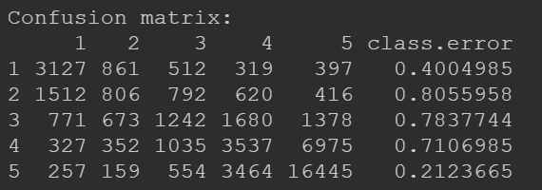

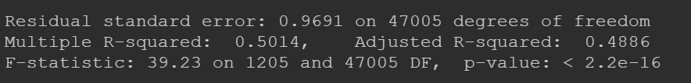

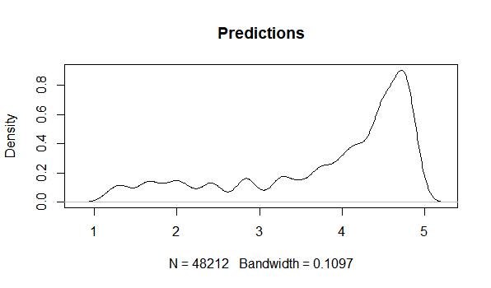
Also, we present the density plot of the real data and our predicted data with the train/test split:

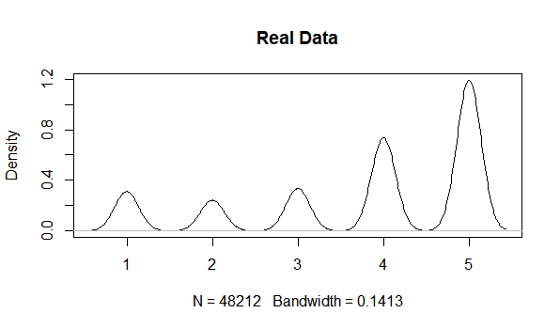

All in all, we believe that our MLR model and Random Forest model achieve a relatively high RMSE (roughly equals 0.86) performance given the limitations of our choices of models. After testing multiple ways to have a better result of calculating the rate, we realized that our model is the most accurate possible, because our Kaggle result is the most accurate out of all the groups who are participating for the project 2. Our clear and direct method can make machines successfully predict the rate through the reviews without human’s understanding.

For future improvements, we can conduct feature selection with VIF regression (Lin et al, 2011) to increase the interpretability of the MLR model to further refine the positiveScore and negativeScore; also, this will save more computational sources during model fitting. Moreover, we might consider multinomial logistics regression to improve the prediction accuracy. Besides, add error estimation with bootstrap to make the model prediction more comprehensive. Finally, we might try to use newly-come-up features (less than 5) as predictors for both MLR and random forest instead of fitting all words’ occurrence to make the model more concise and increase the interpretability.

References:

Lin, D., Foster, D. P., & Ungar, L. H. (2011). VIF Regression: A Fast Regression Algorithm for Large Data. Journal of the American Statistical Association, 106 (493), 232-247. http://dx.doi.org/10.1198/jasa.2011.tm10113

